Deep Learning Challenge:

Scope:

The nonprofit foundation Alphabet Soup wants a tool that can help it select the applicants for funding with the best chance of success in their ventures. With your knowledge of machine learning and neural networks, you’ll use the features in the provided dataset to create a binary classifier that can predict whether applicants will be successful if funded by Alphabet Soup.

Results:

We removed information that is not needed to start, dropping EIN and NAME the remaining columns are potentials to be used in the models built. Next, a split for training and testing occurred. Target of “IS_SUCCESSFUL” with values of 1 for yes and 0 for no is set. Binning of CLASSIFICATION value and analysis of APPLICATION data. Locating cutoff points to finishing binning variables together with the unique value selected. Finally encoding by using get_dummies ().

Training Models:

To be thorough, LogisticRegression, Random_forest, XGBoost and Neural Network models are used to find the most accurate model.

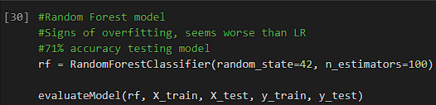

Comparing LogisticRegression, Random_forest and XGBoost we can see XGBoost had the highest accuracy of %72 along with the LogisticRegression model. However, with ROC Curve and Briar score (1943.30) of the XGBoost model would make XGBoost the better model.

The first Neural Network consists of two hidden layers with 200 epoch, producing 403 parameters holds an accuracy of 72% on the training set and .7822% on the model test set ROC Curve

The second Neural network consists of three hidden layers with 50 epoch, producing 6,271 parameters that holds an accuracy of 72% on the training set and .7818% on the model test set ROC Curve. Significantly more parameters, just slightly higher accuracy.

The final Neural Network consists of four hidden layers with 80 epoch, producing 1,737 parameters that holds an accuracy of 73% on the testing set and .7818% on the model test set ROC Curve. Middle ground amount for parameters and produces the same results as the first Neural Network ran.

